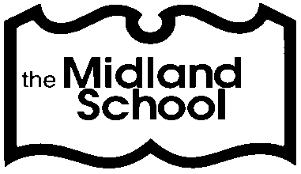
The Midland School Presents
A Free, Highly Important POAC Workshop:

Hidden Dangers – Keeping Children and Adults with Autism and Other Developmental Disabilities Safe in the Community, School, and Home
Tuesday, March 26, 2019
6:30-9:00pm
The Midland School Great Room
94 Readington Road
Branchburg, NJ
POAC’s Hidden Dangers Program educates parents, family members, and professionals working with children and adults with autism and other special needs and disabilities about issues relating to safety, emergency preparedness, and crisis intervention. It is presented in a format that addresses a variety of special needs and levels of functioning across the life span. Specifically, the program will cover:
- How to address wandering and what GPS and other tracking devices are available
- Emergency and Disaster Preparedness
- Fire Safety Issues
- Sexuality and Personal Safety
- Internet Safety
- Bullying
- Behavioral interventions including social stories, activity schedules, visual cues, and more
- School and Transportation Issues
- Resources for ongoing support and assistance
- Physical modifications to the home and classroom
The program will offer concrete suggestions and strategies that can be applied immediately to increase safety and decrease risk at home, in the classroom, and in the community. The focus will be relevant and critical for families with individuals of all disabilities.
The information in this workshop could save your child’s/student’s life.

This presentation has been graciously sponsored and made possible by
The Midland School Parents’ Association.

If you plan to attend this very informative event, please fill out and return the form below by Friday, March 22, 2019. Hope to see you on March 26!
Please return to Dr. Tom Enos by March 22, 2019 (Hidden Dangers)

Name Phone

